1 What is Blender

# What is Blender?

Blender is a free, open-source 3D graphics software that allows users to create 3D models, animations, visual effects, and a whole lot more.



# How do I get Blender?

You can download the latest version of Blender from the website [here](https://www.blender.org/download/). As of this writing, the latest version is 4.3.1. It is constantly being updated and that is because this project has a fantastic bunch of web developers who are dedicated to making sure that this program has the latest and greatest bells and whistles. And if you don’t think that just because this software is free that it can’t be worth a whole lot of anything, then you need to think again, because you will find that Blender is everything that it says it is, and a whole lot more. A full functioning 3D project that is just perfect for creating just about anything in this world of 3D that your heart desires.

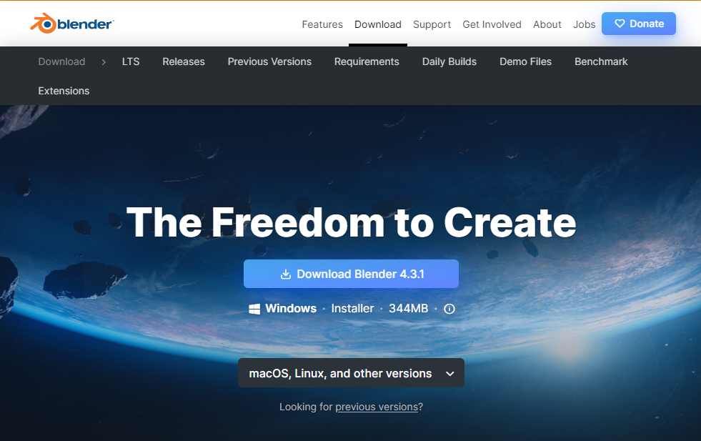

So, what are you waiting for? Download this program today and then let’s start showing you in our next tutorial just what Blender is able to do.